Software Requirements Specification

for

Electronic Medical Information System (EMIS)

Prepared by: Sergio Falcon

Daniel Greenless

Jae Seo

Sanjay Nadaraja

John Callaway

Octorber 30, 2016

Table of Contents

Table of Contents 1

Table of Figures 1

1. Introduction 3

1.1 Purpose 3

1.2 Scope 3

1.3 Overview 3

1.4 References 3

3. Specific Requirements 4

3.1 Functional Requirements 4

3.1.1 Use Case Diagrams and Description 4

3.1.2 Sequence Diagrams 6

3.1.3 Class Diagrams and descriptions 22

3.1.4 State Diagrams and Descriptions 24

3.1.5 GUI Screenshots and Walkthrough 25

3.1.6 Use Case Story Backlog 63

Table of Figures

Figure 1: Use Case Diagram 5

Figure 2: Sequence Diagram - Login 6

Figure 3: Sequence Diagram - Edit Personal Info 7

Figure 4: Sequence Diagram - Edit Insurance Info 8

Figure 5: Sequence Diagram - Schedule Appointment 9

Figure 6: Sequence Diagram - Pay Patient Bill 10

Figure 7: Sequence Diagram - Pay Insurance Bill 10

Figure 8: Sequence Diagram - View Medical Record 11

Figure 9: Sequence Diagram - View Treatment Receipt 12

Figure 10: Sequence Diagram - Update Medical Record 13

Figure 11: Sequence Diagram - Edit Medical History 14

Figure 12: Sequence Diagram - Add Diagnosis 15

Figure 13: Sequence Diagram - Add Lab Results 16

Figure 14: Sequence Diagram - Add Medical Condition 17

Figure 15: Sequence Diagram - Billing Application 18

Figure 16: Sequence Diagram - Fill Prescription 19

Figure 17: Sequence Diagram - Order Lab 20

Figure 18: Sequence Diagram - Order Prescription 21

Figure 19: Class Diagram 23

Figure 20: State Machine Diagram - Email 24

Figure 21: State Machine Diagram - Login 24

Figure 22: GUI Login 25

Figure 23: GUI Patient Main - “View Medical Record” 26

Figure 24: GUI Patient - Select Medical Record 27

Figure 25: GUI Patient - View Medical Record 28

Figure 26: GUI Patient Main - “Add Medical History” 29

Figure 27: GUI Patient - Add Medical History 30

Figure 28: GUI Patient Main - "Update Personal Information" 31

Figure 29: GUI Patient - Update Personal Information 32

Figure 30: GUI Patient Main - "Update Insurance Information" 33

Figure 31: GUI Patient - Update Insurance Information 34

Figure 32: GUI Patient Main - "Schedule Appointment" 35

Figure 33: GUI Patient - Schedule Appointment 36

Figure 34: GUI Patient Main - "Message Clinic" 37

Figure 35: GUI Patient - Send Message 38

Figure 36: GUI Patient Main - "View/Pay Bill Online" 39

Figure 37: GUI Patient, Insurance - View/Pay Bill 40

Figure 38: GUI Clinic Main - "View/Update Patient Information" 41

Figure 39: GUI Clinic - Enter Patient Name 42

Figure 40: GUI Clinic - View Patient Information 43

Figure 41: GUI Clinic Main - "View/Update Calendar" 44

Figure 42: GUI Clinic, Doctor - View/Update Calendar 45

Figure 43: GUI Clinic Main - "Message Patient" 46

Figure 44: GUI Clinic - Message Patient 47

Figure 45: GUI Clinic Main - "Billing Application" 48

Figure 46: GUI Clinic - Billing Application 49

Figure 47: GUI Nurse Main 50

Figure 48: GUI Doctor Main 51

Figure 49: GUI Pharmacy Main 52

Figure 50: GUI Lab Main 53

Figure 51: GUI Insurance Main 54

Figure 52: GUI Nurse, Doctor, Pharmacy, Lab, Insurance - Enter Patient Name 55

Figure 53: GUI Nurse, Doctor, Pharmacy, Lab, Insurance- View Patient Information 56

Figure 54: GUI Nurse, Doctor - Select Medical Record 57

Figure 55: GUI Nurse, Doctor - Add Medical Record 58

Figure 56: GUI Doctor - Submit Prescription 59

Figure 57: GUI Doctor - Submit Lab Tests 60

Figure 58: GUI Lab - Fill Lab Tests 61

Figure 59: GUI Pharmacy - Fill Prescription 62

# Introduction

## Purpose

This Software Requirements Specification document has been created in order to guide the software development team in creation of the Electronic Medical Information System (EMIS) and allow stakeholders to view the design aspects. It describes in detail who will be able to use the system and the functionality of what can be performed by each user.

## Scope

The software being created is called the Electronic Medical Information System(EMIS). It will provide patients, doctors, nurses, clinical staff, insurance agencies, pharmacies, and lab facilities a way to communicate with greater efficiency and security than current paper methods. A patients medical history and current care will all be consolidated to a single system that allows selected access to view what each party member requires. It will not replace physical visits between a patient and doctor. The EMIS will allow documentation of all sorts, including scanned images, audio recordings, prescriptions, lab orders, vital readings, diagnosis’, and medical history to be accessed remotely.

## Overview

*The rest of this document contains the functional requirements for the EMIS. It contains a Use Case Diagram with a description and detailed table description for each identified use case. There is also a Class Diagram and description for how the different facets of the software will interact within the system.*

## References

IEEE Computer Society. Software Engineering Standards Committee, and IEEE-SA Standards Board. "IEEE Recommended Practice for Software Requirements Specifications." Institute of Electrical and Electronics Engineers, 1998.

*Arlow, Jim, and Ila Neustadt. UML 2 and the Unified Process: Practical Object-oriented Analysis and Design. Upper Saddle River, NJ: Addison-Wesley, 2005. Print.*

# Specific Requirements

## Functional Requirements

### Use Case Diagrams and Description

Use case diagram description: The use case diagram shows the different actors that interact with the EMIS web app and how they interface with the system functionality. The patient has patient information that incorporates medically relevant information like height, weight, age, and gender as well as information entered by medical professionals like doctors and nurses like blood pressure, test results, prescription orders, and diagnoses. The patient information also includes information relevant to hospital administrivia like insurance providers and billing information.

Figure : Use Case Diagram

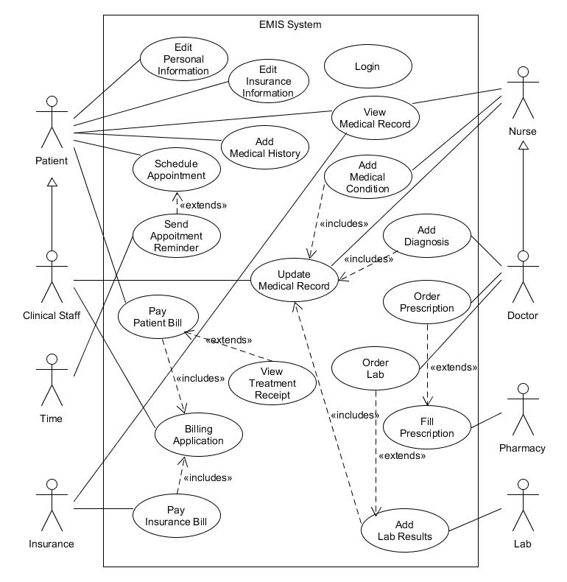

### Sequence Diagrams

Figure 2: Sequence Diagram - Login

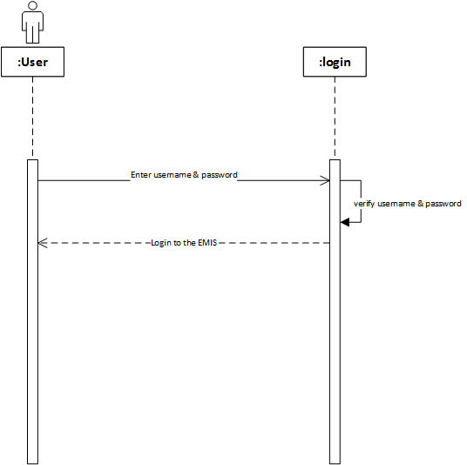

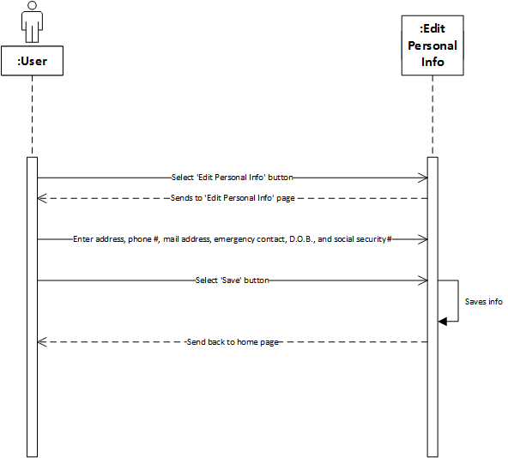

Figure 3: Sequence Diagram - Edit Personal Info

Figure 4: Sequence Diagram - Edit Insurance Info

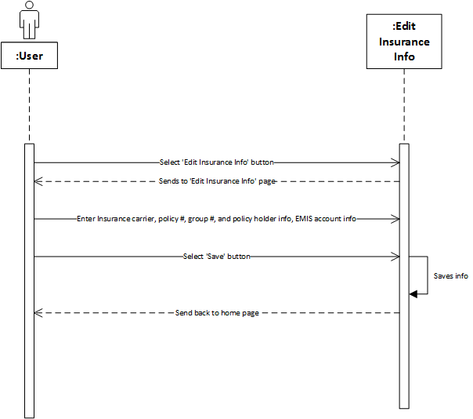

Figure 5: Sequence Diagram - Schedule Appointment

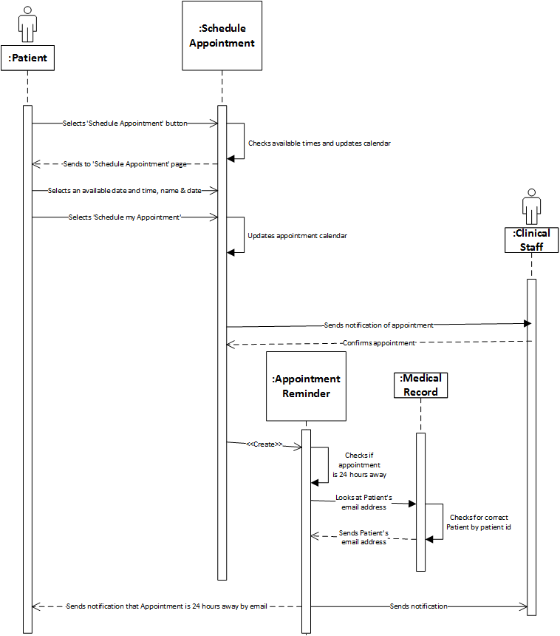

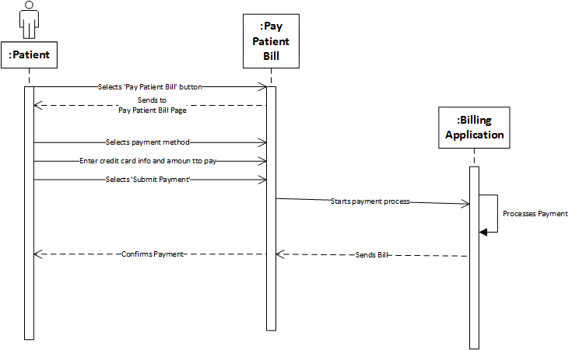

Figure 6: Sequence Diagram - Pay Patient Bill

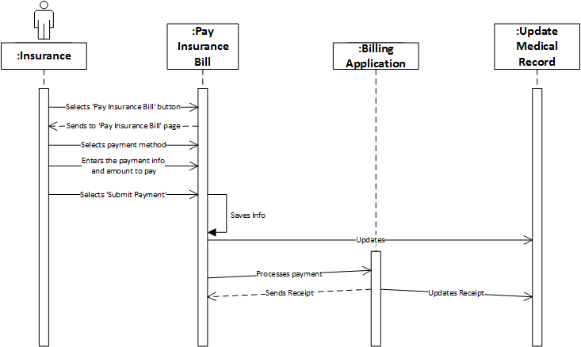

Figure 7: Sequence Diagram - Pay Insurance Bill

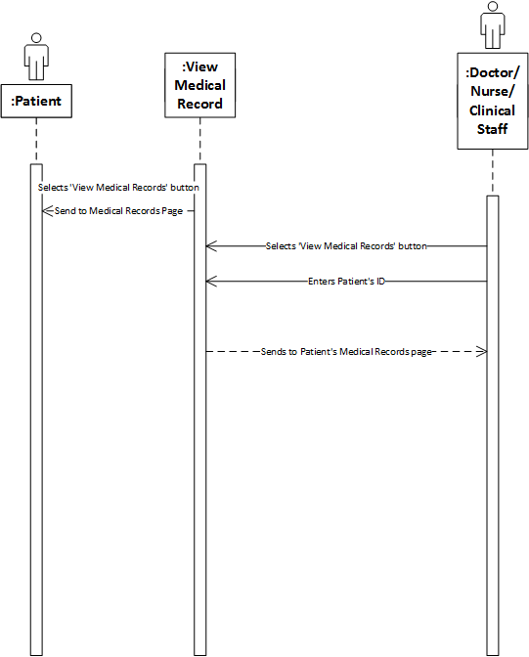

Figure 8: Sequence Diagram - View Medical Record

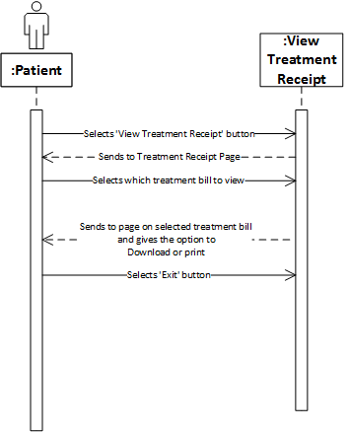

Figure 9: Sequence Diagram - View Treatment Receipt

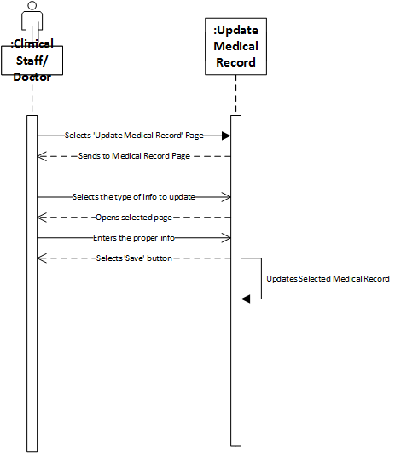

Figure 10: Sequence Diagram - Update Medical Record

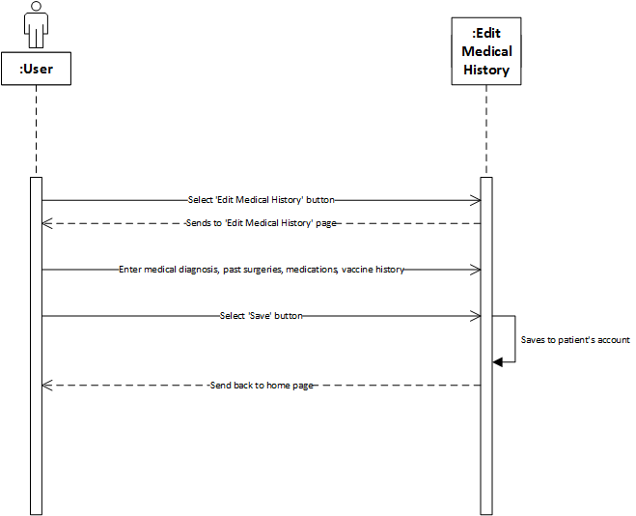

Figure 11: Sequence Diagram - Edit Medical History

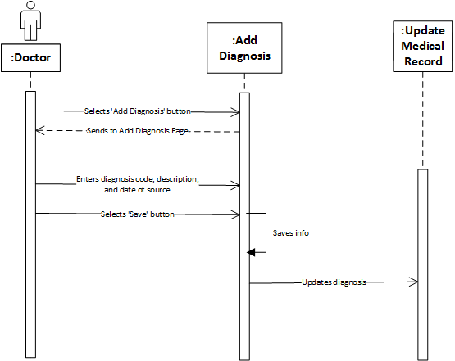

Figure 12: Sequence Diagram - Add Diagnosis

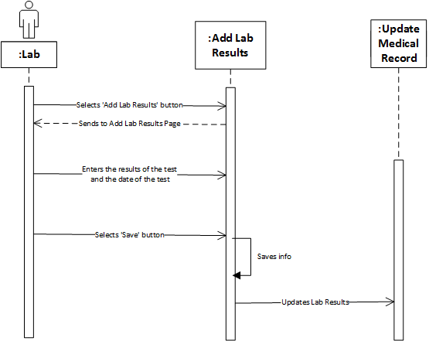

Figure 13: Sequence Diagram - Add Lab Results

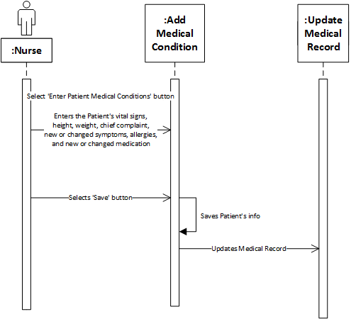

Figure 14: Sequence Diagram - Add Medical Condition

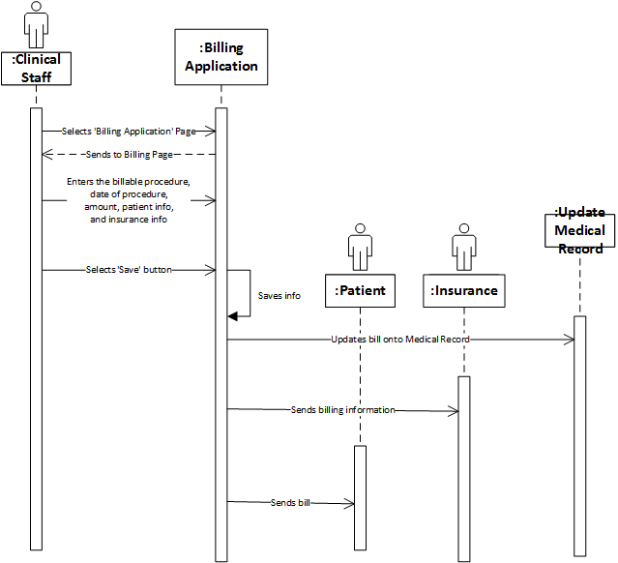

Figure 15: Sequence Diagram - Billing Application

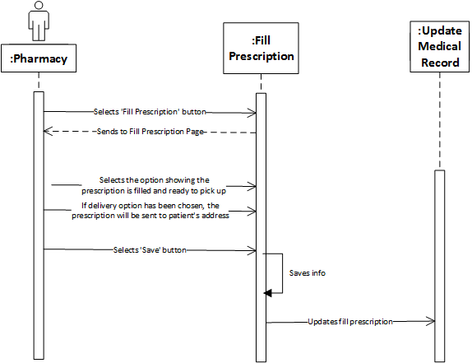

Figure 16: Sequence Diagram - Fill Prescription

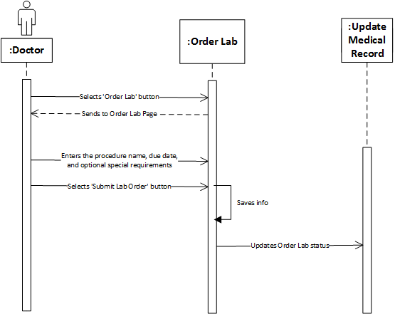

Figure 17: Sequence Diagram - Order Lab

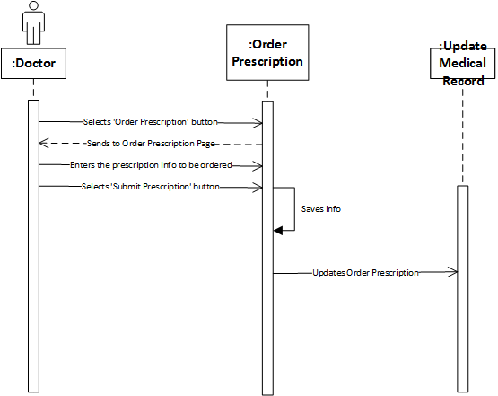

Figure 18: Sequence Diagram - Order Prescription

### Class Diagrams and descriptions

The EMIS class has a log in function which will direct you to either logging in or creating an account. The account is split into patient and medical staff account. The medical staff account proceeds to branch out into three classes, nurse, doctor, and receptionist account which all have different roles to play. The actors in this class diagram are the following, patient, nurse, doctor, receptionist, time, pharmacy, and insurance.

The patient has access to setting up an appointment, checking patient chart, checking lab results, checking personal information, and messaging the receptionist. The nurse can access patient records and medical information and change things like height, weight, blood pressure, and temperature. Doctors can check and edit the patient chart and give patient a diagnosis and other things as needed. Doctors can also check lab results after processing.

Receptionist can generate the bills, check the schedule to create and delete appointments, receive payments, and contact the patient. Time is a class that uses a reminder function which is used to set up a reminder for the upcoming appointment for the patient. The pharmacy will handle the prescription for the patient after insurance. The insurance class gets the user ID to process.

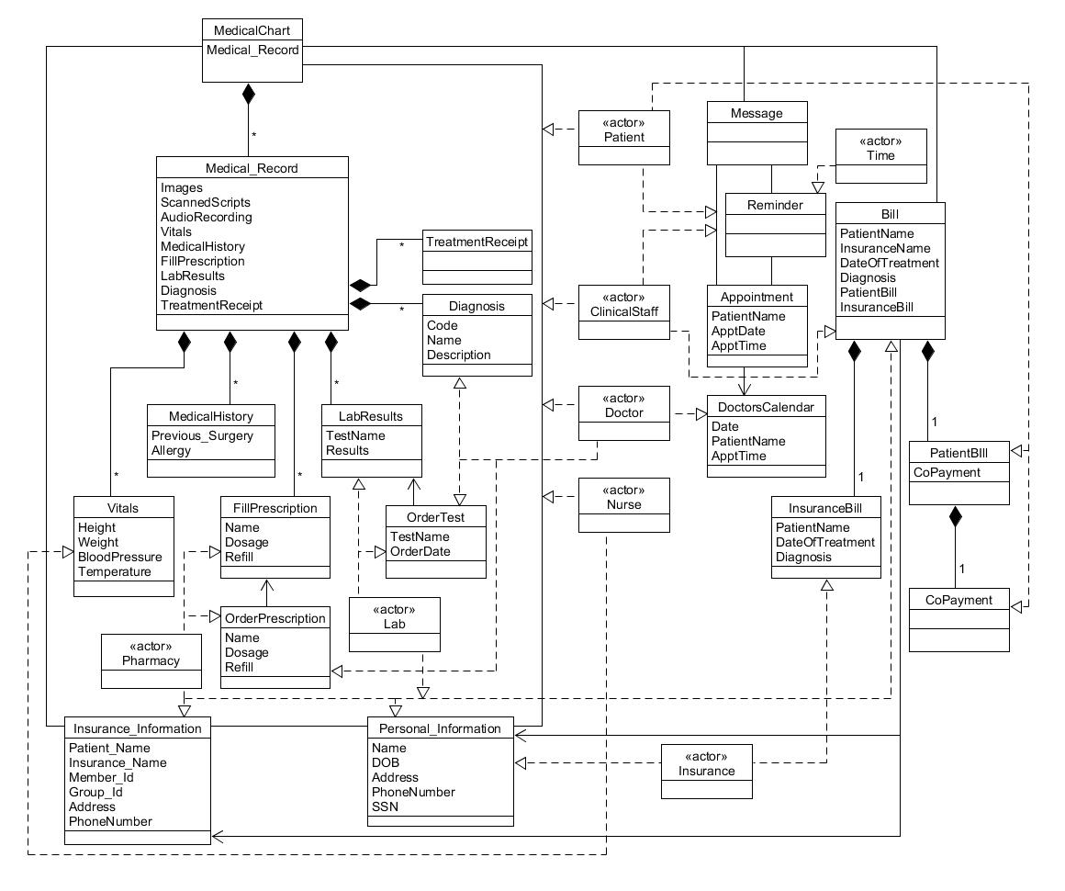

Figure 19: Class Diagram

### State Diagrams and Descriptions

The state machine in Figure 20 starts with the user logged in. This state can go towards either Read Email or Write Email states. If the user choosed to open email, it will result in the Read Email state, they are then able to close email, resulting in the Logged In state. If the user goes for Messaging, the program will be in the Write Email state. It can branch one of two ways, either the Cancel or Send. If Cancel, the resulting state is Logged in. If Send, they will result in a state of Emailing. Which will handle the email and then procede back into the Logged in State.

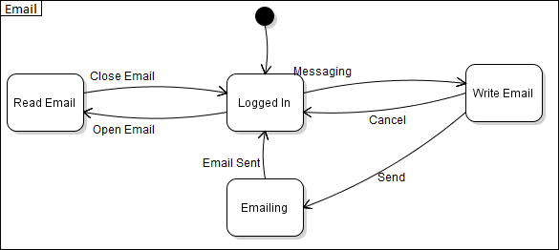

Figure 20: State Machine Diagram - Email

The state machine in Figure 21 starts with the user in a logged out state. the user then has the option of logging in, and goes through the verify login step. If it is verified, it procedes to the logged in state. Otherwise it will result in a failed log in fall back into the Logged Out state. Once in the Logged In state, they can procede to Log out, resulting in being Logged Out.

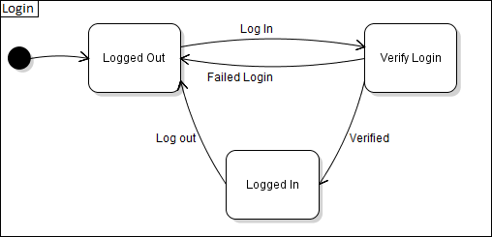

Figure 21: State Machine Diagram - Login

### GUI Screenshots and Walkthrough

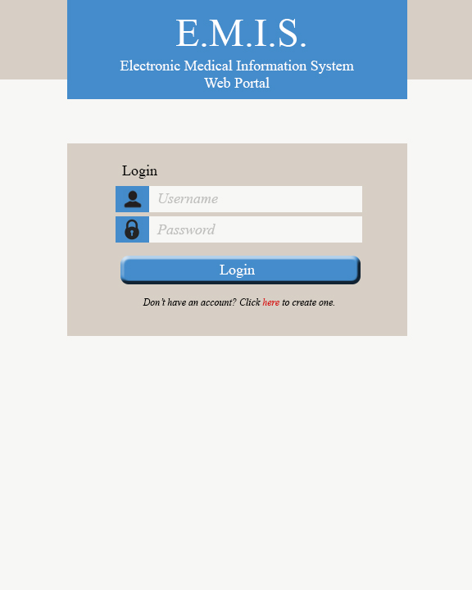This is the main login page. The user will enter their username and password then click the Login button. If the user does not have an account, they can click the link below the login button to request a new account.

Figure 22: GUI Login

After the login button is clicked, the main page will load. The main page is unique for each of the account types: Patient, Clinical Staff, Nurse, Doctor, Pharmacy, Laboratory, and Insurance. We’ll follow the patient options first.

Patient Main: User clicks on “View Medical Record”

Figure 23: GUI Patient Main - “View Medical Record”

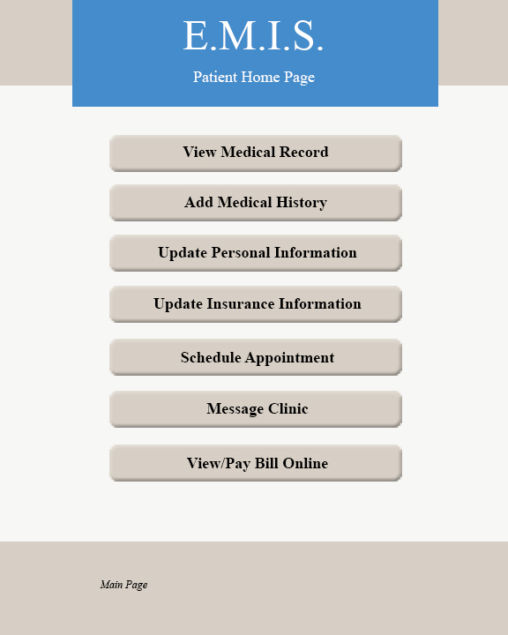

A listing of medical records will be shown by date. Then a date is selected and clicked.

Figure 24: GUI Patient - Select Medical Record

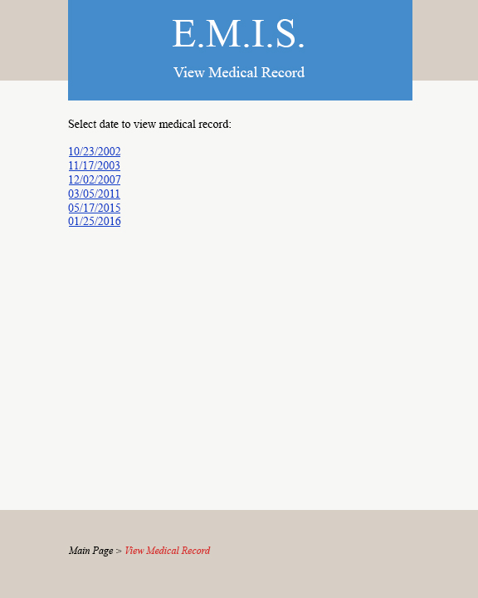

The medical record for the date chosen is shown in detail. The patient can view the information but cannot change any details. At the bottom, they can then click the “Main Page” link to return to the patient main page.

Figure 25: GUI Patient - View Medical Record

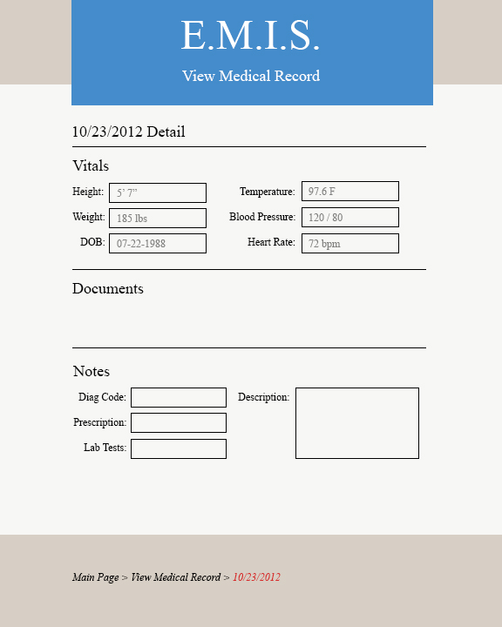

The patient selects “Add Medical History” to add past events as a medical record into their medical chart.

Figure 26: GUI Patient Main - “Add Medical History”



In this section, the patient enters the date of the history item, the description of the surgery, visit, or treatment, and upload any additional documentation they may have. Clicking the “Submit History” button will add the item to the database and return the user to their main page.

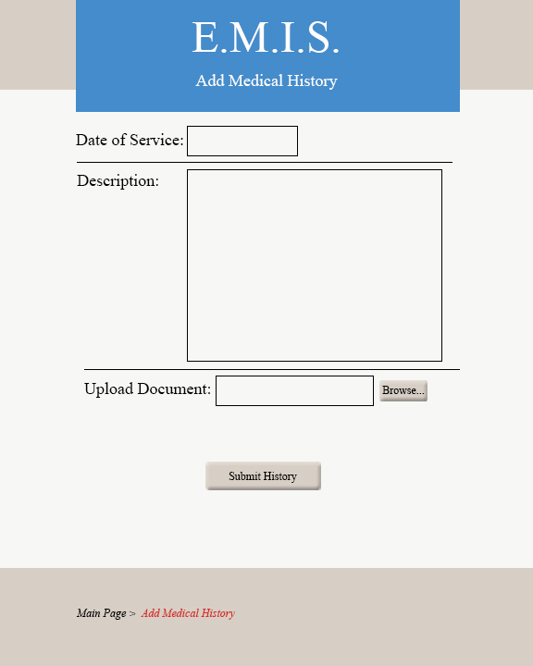

Figure 27: GUI Patient - Add Medical History

The patient clicks “Update Personal Information”.

Figure 28: GUI Patient Main - "Update Personal Information"



Here the patient can view all their personal information and update anything as needed. When complete, they can click “Submit Updates” which will update the database and take them back to the main page.

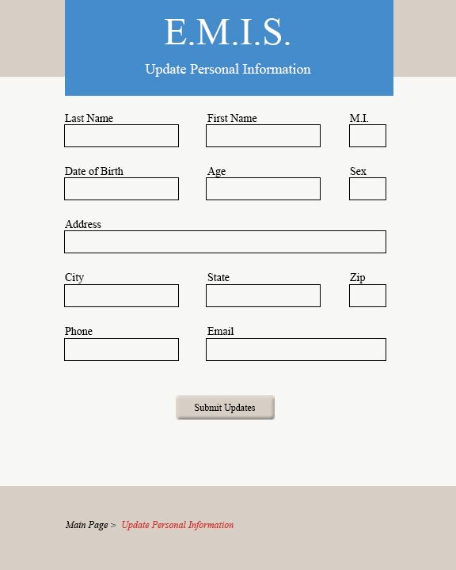

Figure 29: GUI Patient - Update Personal Information

The patient selects “Update Insurance Information”.

Figure 30: GUI Patient Main - "Update Insurance Information"



The patient can view or update their insurance information. When “Submit Updates” is clicked, they care taken back to the main page.

Figure 31: GUI Patient - Update Insurance Information

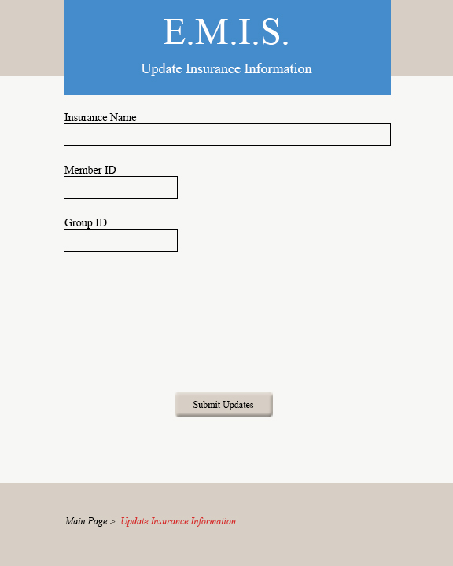

The patient selects “Schedule Appointment” from the main page.

Figure 32: GUI Patient Main - "Schedule Appointment"



The enters their name, reason for visit, and the doctor they’d like to see and clicks “Submit Request”. An email is then sent to the clinical staff who can find an opening on the calendar.

Figure 33: GUI Patient - Schedule Appointment

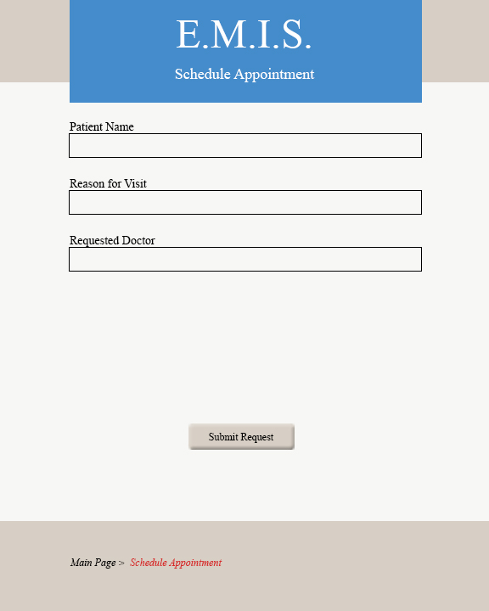

The patient clicks on “Message Clinic”.



Figure 34: GUI Patient Main - "Message Clinic"

The patients enters their name, a message, then clicks on the “Send Message” button and they are returned to the main page. An email is sent with the information to the clinical staff.

Figure 35: GUI Patient - Send Message

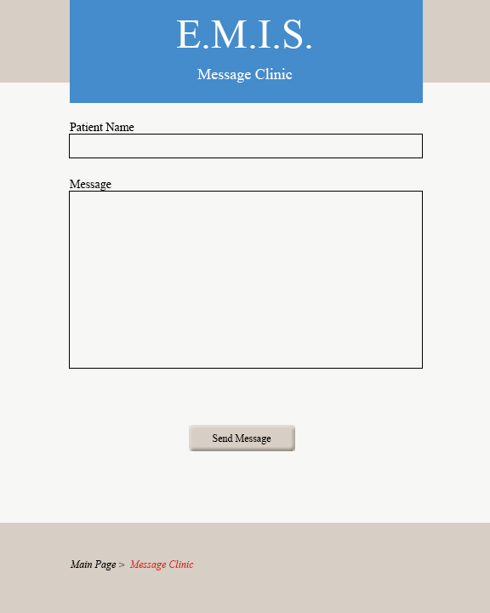

The patient clicks “View/Pay Bill Online”.

Figure 36: GUI Patient Main - "View/Pay Bill Online"



The patient can view all pending charges for their account. Then they can enter credit card information and pay those charges by clicking the “Submit Payment” button which then takes them back to the main page. The insurance user has access to this as well to pay their portion.

Figure 37: GUI Patient, Insurance - View/Pay Bill

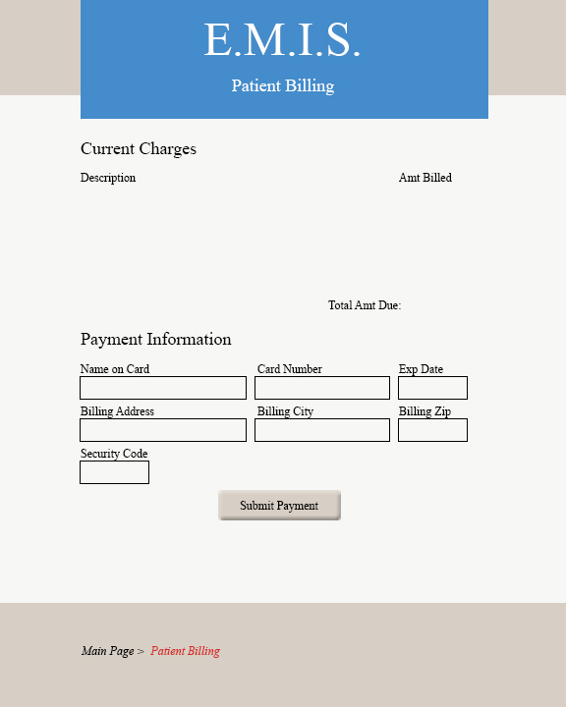

This is the main page for the clinical staff user. Clicking “View/Update Patient Information” takes them to a page to enter the patient name.

Figure 38: GUI Clinic Main - "View/Update Patient Information"

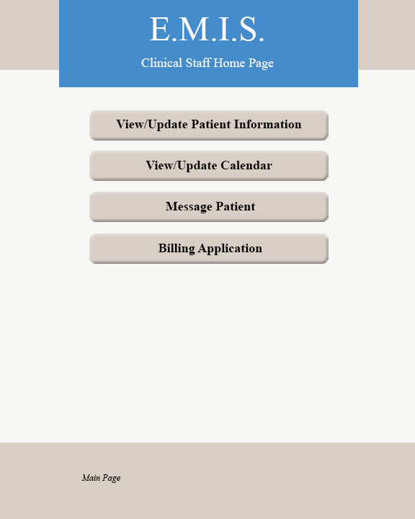

The clinical staff enters the patient name and clicks the submit button.

Figure 39: GUI Clinic - Enter Patient Name

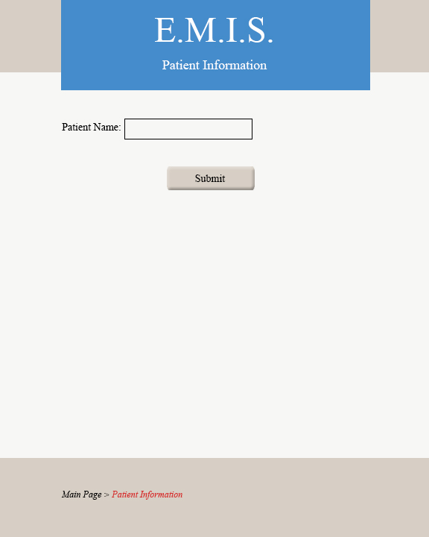

The clinical staff user can view the patient personal and insurance information. They also have the option to update the information by clicking “Submit Updates” which will then take them back to the main page.

Figure 40: GUI Clinic - View Patient Information

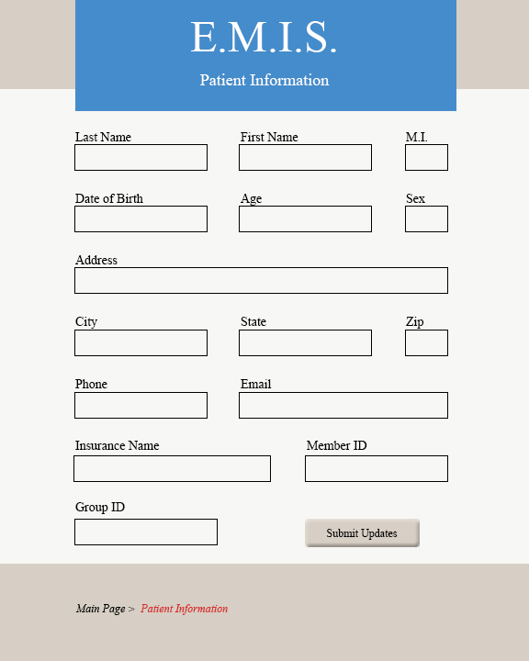

The clinical staff clicks “View/Update Calendar”.

Figure 41: GUI Clinic Main - "View/Update Calendar"



The clinical staff and doctors can view the calendar. Clicking “Main Page” at the bottom returns them to their home page.

Figure 42: GUI Clinic, Doctor - View/Update Calendar

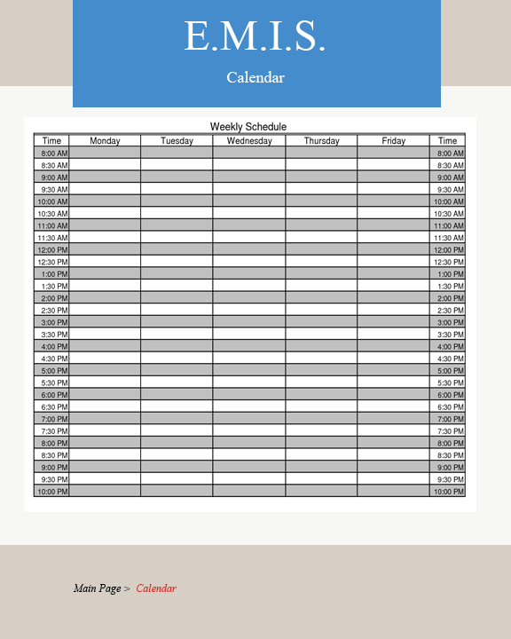

The clinical staff clicks “Message Patient”.

Figure 43: GUI Clinic Main - "Message Patient"



The clinical staff enters the patient email address and a message. After clicking “Send Message” an email is sent to the patient and the clinical staff is returned to the home page.

Figure 44: GUI Clinic - Message Patient

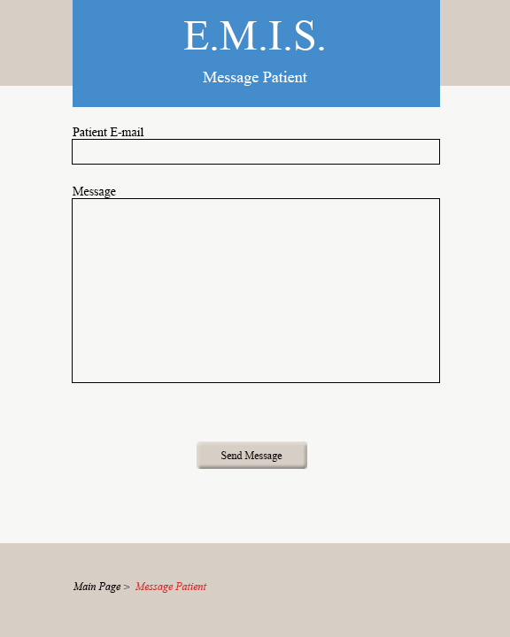

The clinic staff clicks “Billing Application”.

Figure 45: GUI Clinic Main - "Billing Application"



The clinical staff enters the charged items, the patient name, and insurance information. An email is sent to the patient and insurance company that a bill is available and the clinical staff is returned to the home page after clicking “Submit Bill”.

Figure 46: GUI Clinic - Billing Application

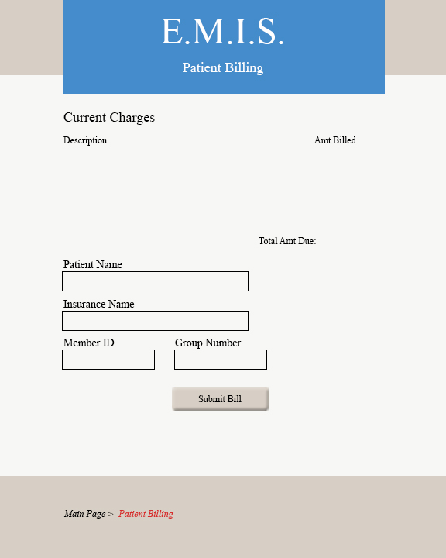

After a successful login, the Nurse, Doctor, Pharmacy, Laboratory, and Insurance see the following main pages:

Figure 47: GUI Nurse Main

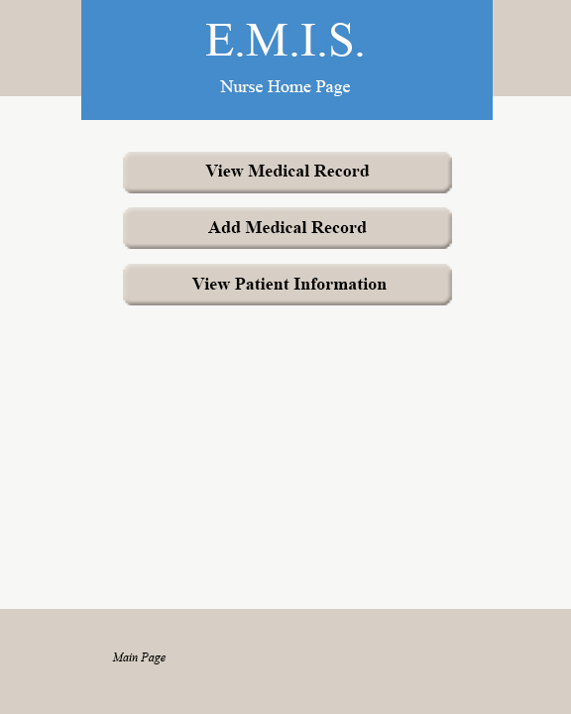

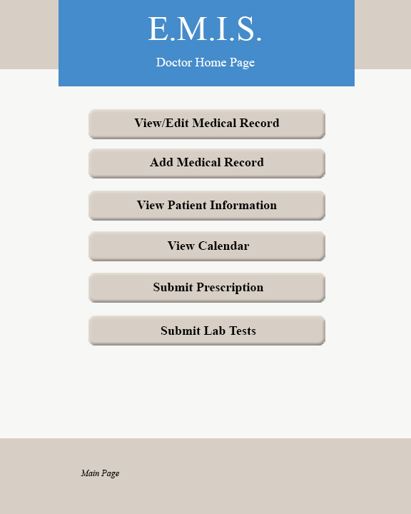

Figure 48: GUI Doctor Main

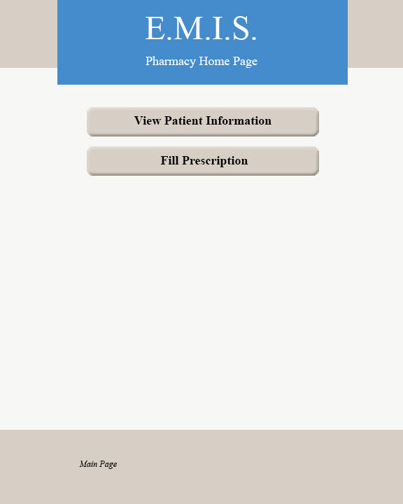

Figure 49: GUI Pharmacy Main

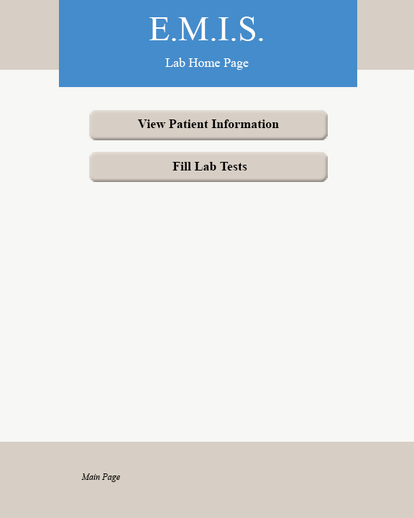

Figure 50: GUI Lab Main

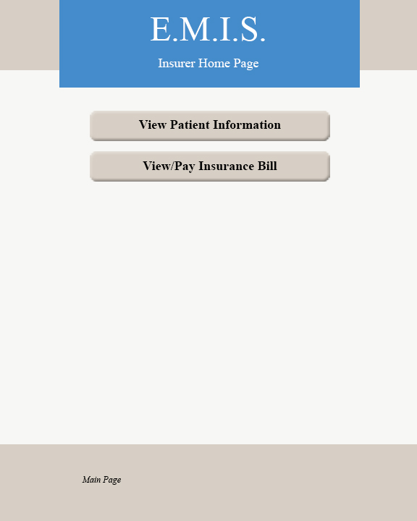

Figure 51: GUI Insurance Main

All five of these user types see the same options when clicking “View Patient Information”. They are presented with this screen to enter a patients name and clicking “Submit” will show the information. They do not have access to change any fields.

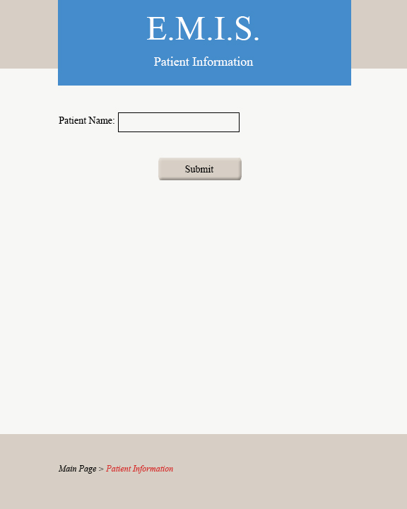

Figure 52: GUI Nurse, Doctor, Pharmacy, Lab, Insurance - Enter Patient Name

The patient information is shown. Clicking “Main Page” at the bottom will take the user to their respective home page.

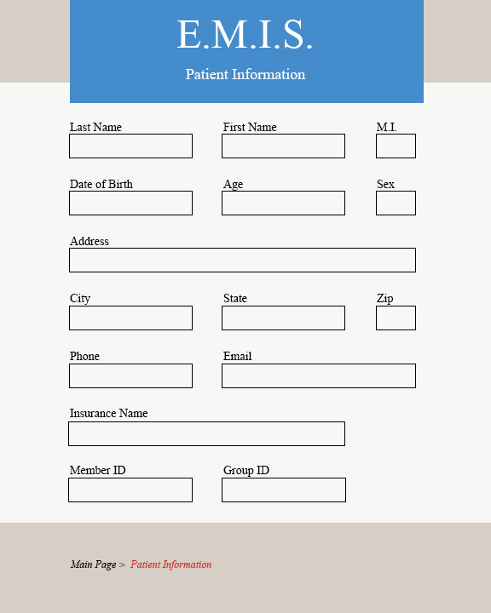

Figure 53: GUI Nurse, Doctor, Pharmacy, Lab, Insurance- View Patient Information

Both the Nurse and Doctor users can “View Medical Records” from their home pages. A patient Name is entered, then a list of records by date is shown for the patient. Clicking a date will show the record for that date.

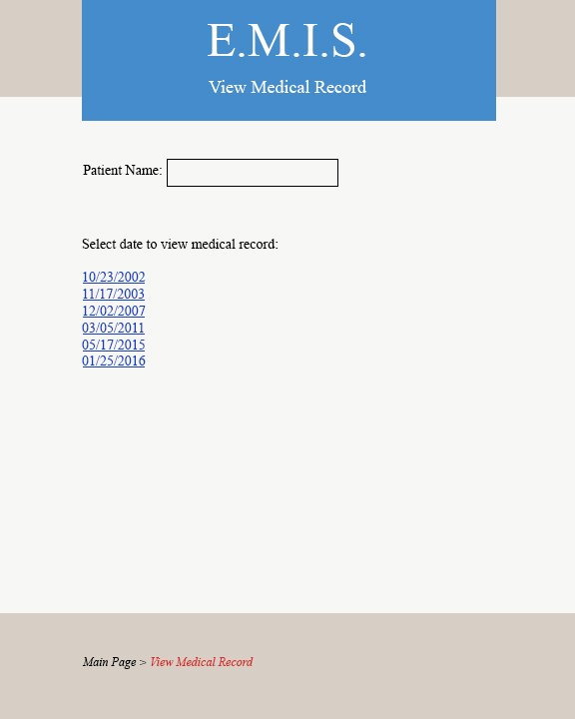

Figure 54: GUI Nurse, Doctor - Select Medical Record

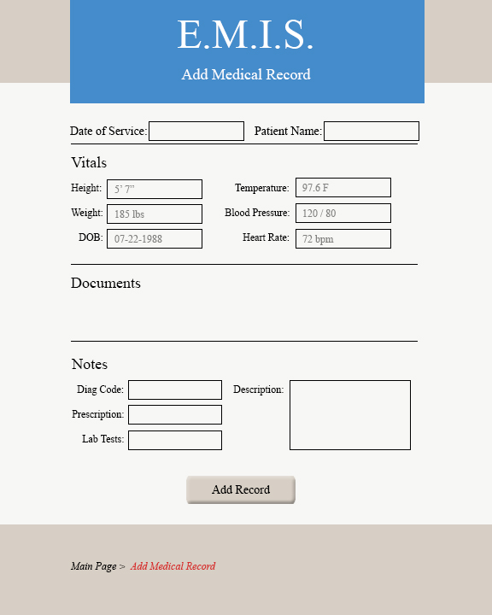Both the Nurse and Doctor users are able to choose “Add Medical Record” from their home pages. Both user types are able to enter the date of service, patient name, and update the Vitals and Documents sections, but only the Doctor can add information in the Notes section. Clicking “Add Record” returns the user to their home page.

Figure 55: GUI Nurse, Doctor - Add Medical Record

The doctor can also select “Submit Prescription” from the main menu. Once the information is entered, clicking “Submit Order” sends the information to the pharmacy and returns to the main menu.

Figure 56: GUI Doctor - Submit Prescription

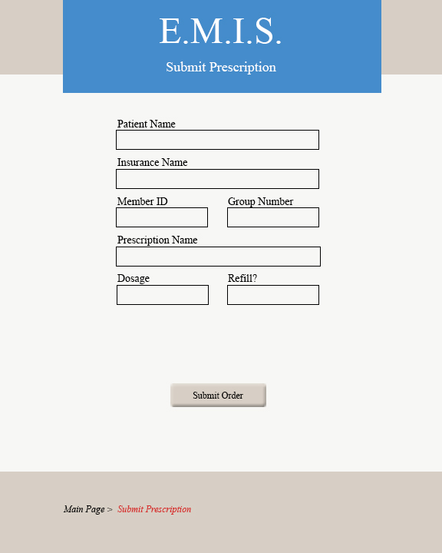

The doctor can also select “Submit Lab Tests” from the main menu. After entering the information, the “Submit Order” button sends the information to the lab and returns the user to the main screen.

Figure 57: GUI Doctor - Submit Lab Tests

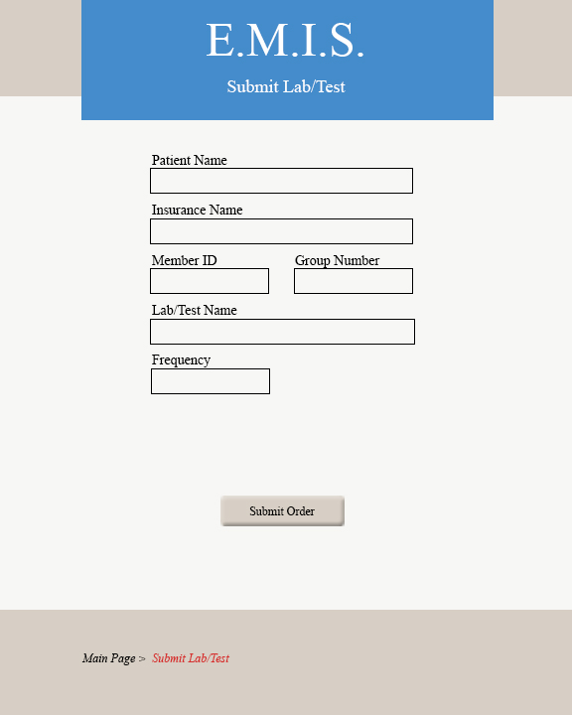

The Lab can select “Fill Lab Tests” from their main screen. Clicking “Submit Results” sends the information back to the doctor and returns the user to the main page.

Figure 58: GUI Lab - Fill Lab Tests

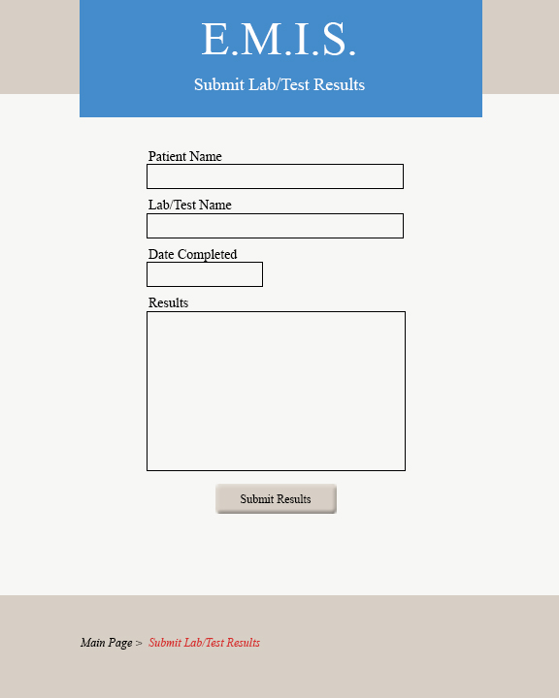

The pharmacy can select “Fill Prescription” from their main screen. Clicking “Submit Fulfillment” sends the information back to the doctor and returns the user to the main screen.

Figure 59: GUI Pharmacy - Fill Prescription

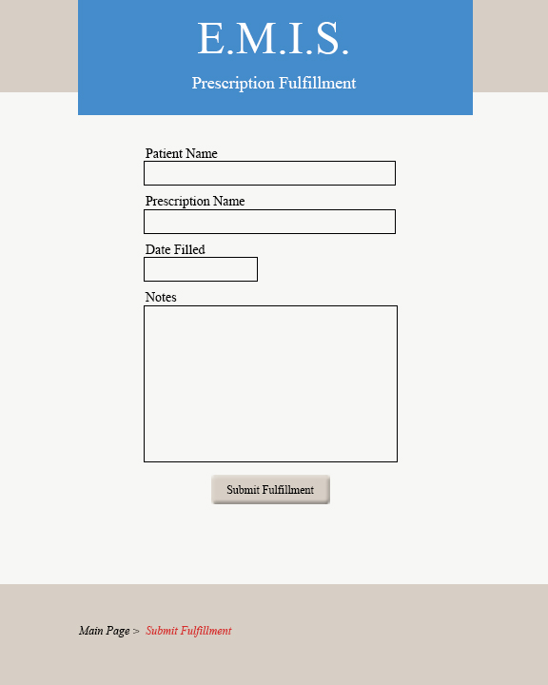

### Use Case Story Backlog

|  |  |  |  |  |  |  |
| --- | --- | --- | --- | --- | --- | --- |
| **Story ID** | **As a/an** | **I want to…** | **so that…** | **Story Points** | ***Priority*** | **Status** |
| 1 | patient | create a new account through the website | I can log into the system | 5 | *optional* | to do |
| 2 | user | login to the site | I can access the system and utilize it's features | 5 | *required* | in progress |
| 3 | administrator | create a new account for users | they can login and use the system | 3 | *optional* | to do |
| 4 | nurse/doctor | enter patient's vitals | it can be saved to the patients chart | 8 | *optional* | to do |
| 5 | doctor | enter patient's vitals, prescriptions, and lab tests | it can be saved to the patients chart | 8 | *optional* | to do |